**PDD PIPELINES & JOBS RUNNING STEPS- MANUALLY**

**STEP 1**:-We have to request to Data Broker team for particular flight (Eg-MH125/5Jun2022) data within the below timelines:

**A.9:00 pm**

**B.12:00 pm**

**C.3:00 pm**

**D.6:00 pm**

1.Dear Data broker team  ,Kindly load the flight data MH125/5Jun2022 at 12 IST.

**STEP 2**:-Confirmation like :

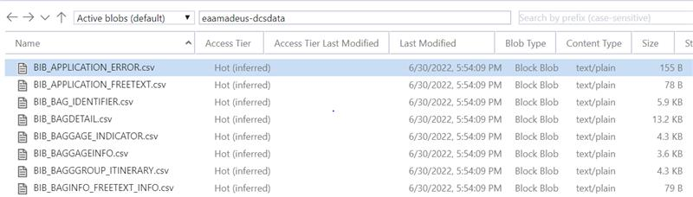

Kindly note that data for MH125/5Jun22 is loaded in BLOB location

**STEP 3**: After scheduled job(12:30 pm Job time) is run then we have to run the pipelines and job after 10 mins (12:40 pm onwards)

**1.Pipelines run in manually:**

1.Open Azure data factory (**masg-1scvpgdb1-df**) :-

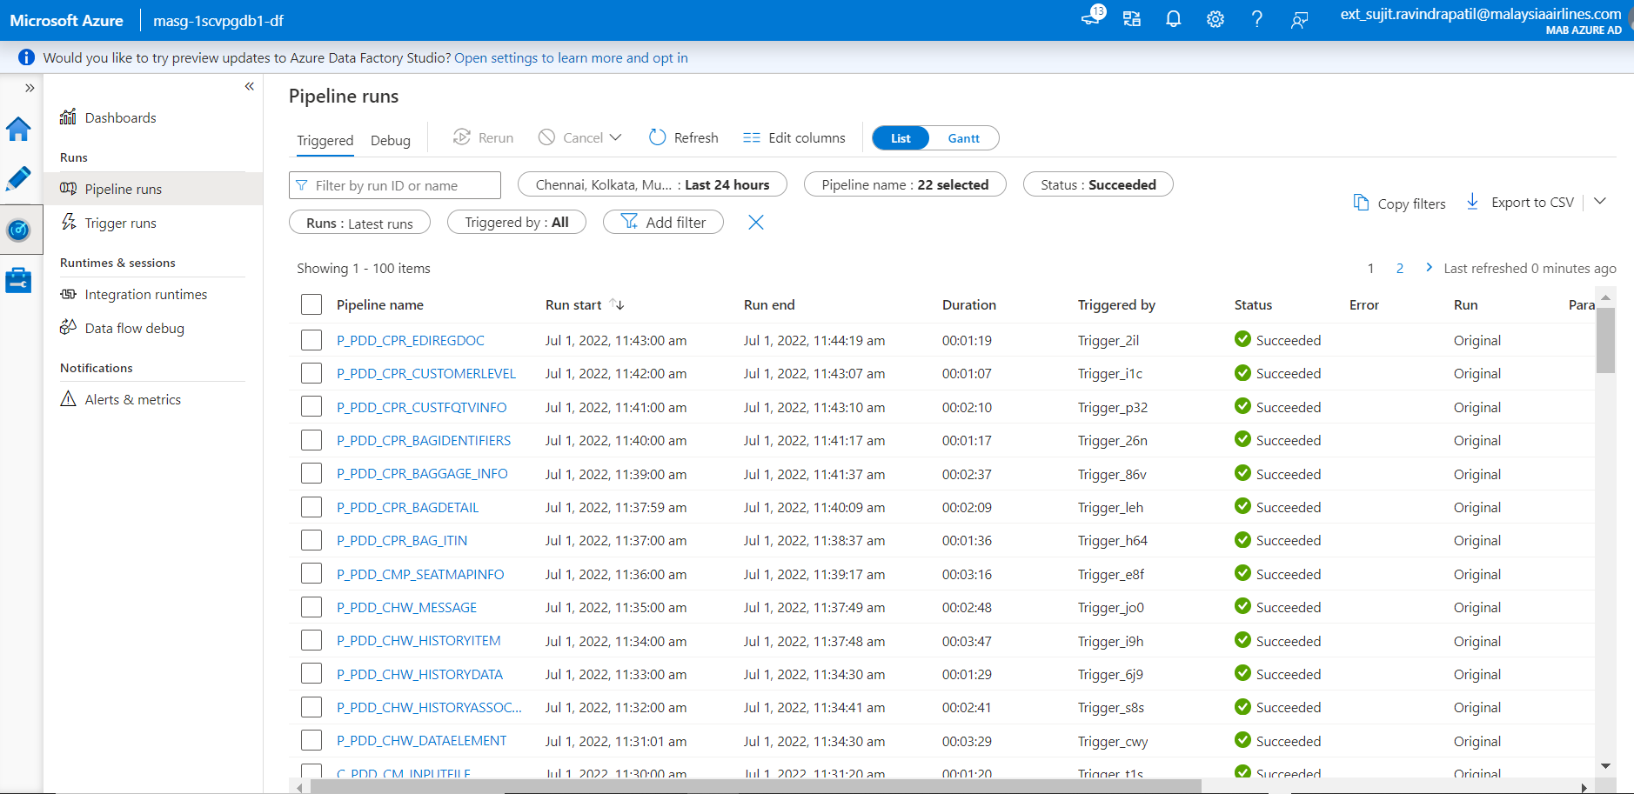

2.Set the Data and time between 11pm to 2:30 pm (Filter):

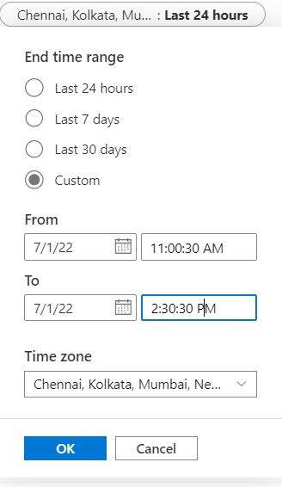

3.After filter we will got 22 pipelines on the screen :

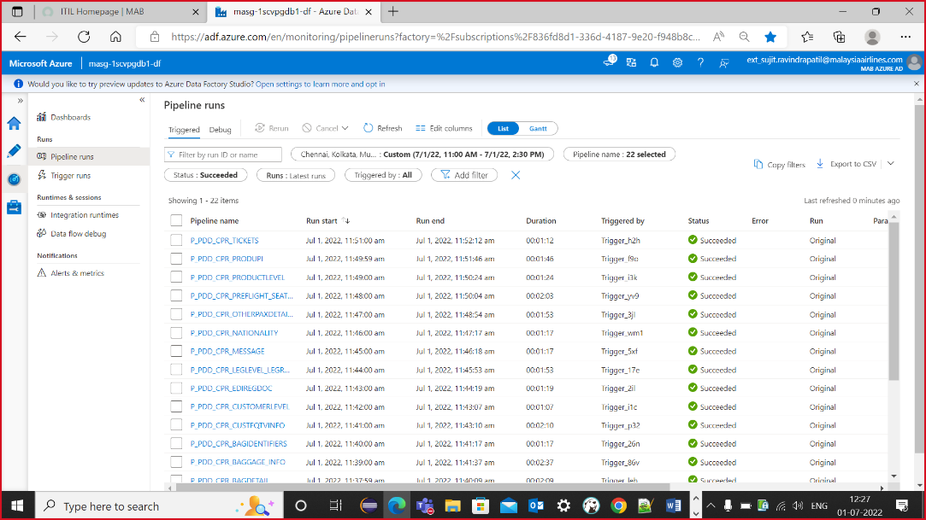

4.Select 22 pipelines and rerun :

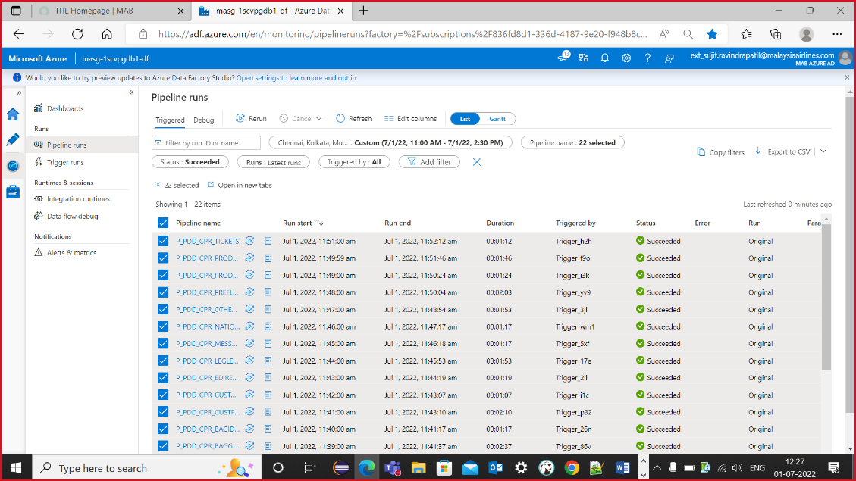

5. Check the Status (**Succeeded=22,In progress=0,Failed=0**)

1.Succeeded

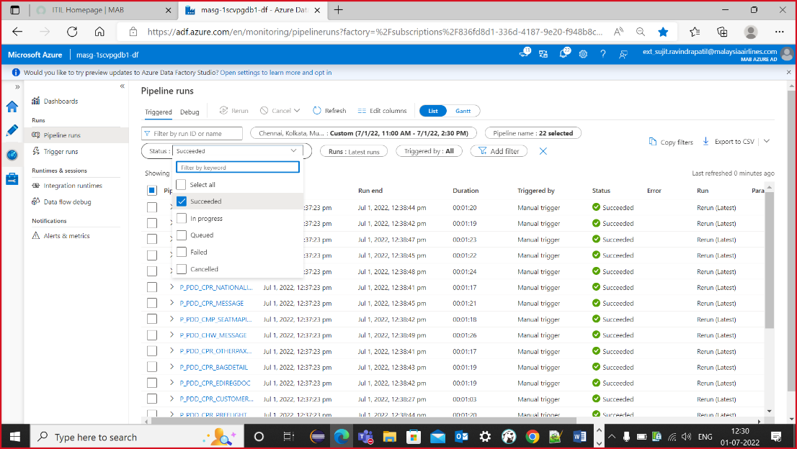

2.In progress:

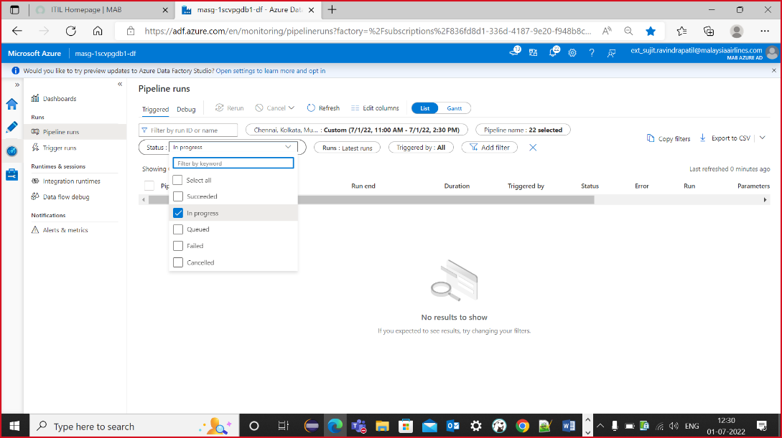

3.Failed:

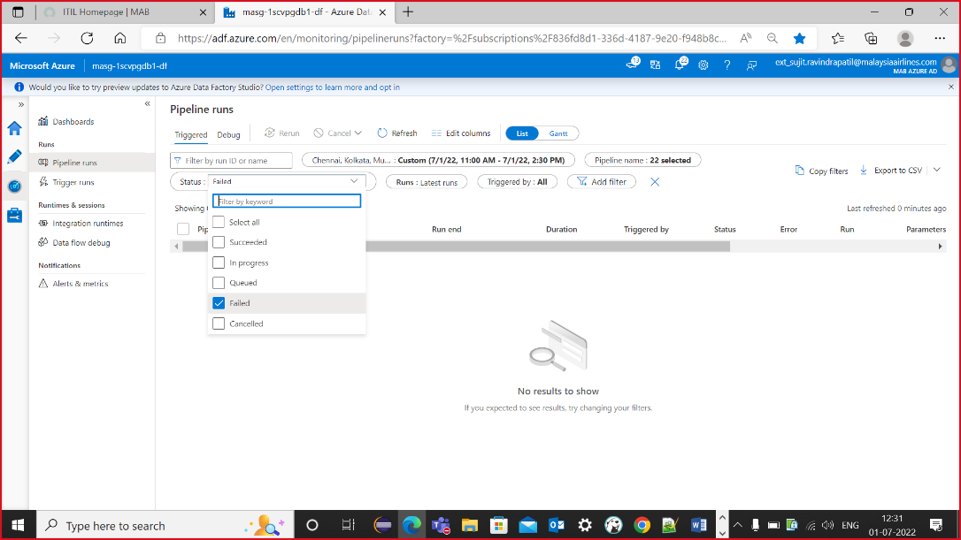

**2.Job run in manually:**

1.Open putty and login in your credentials:

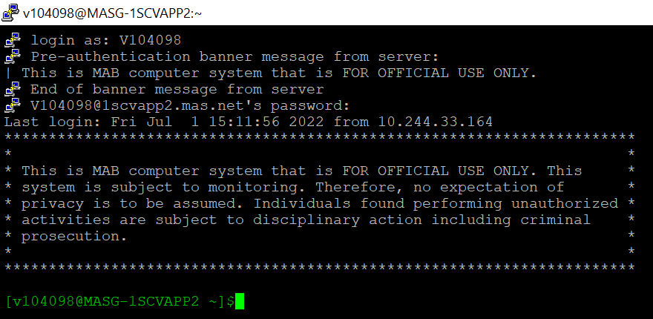

2.Add **(su appadmn**) command and password(**8URm8FFs**)

3.After add (**java -jar /home/appadmn/scvjob/pdd/bin/AMAD_DCS_PDD_VIEWER.jar**) command

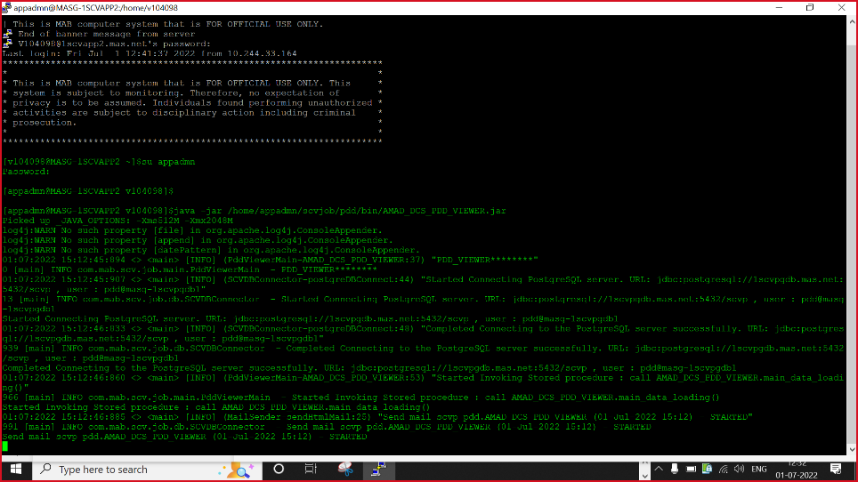

**Job run successfully**

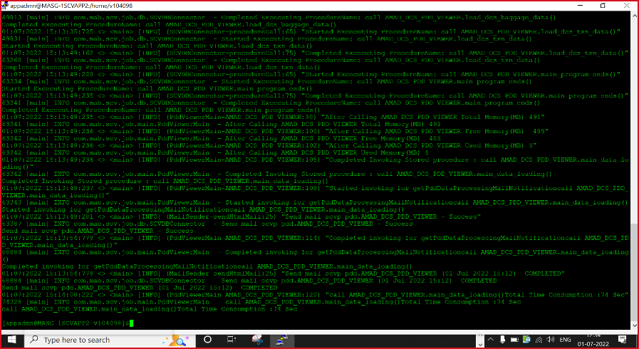

**STEP 4**:After run the pipelines and job we need to validate the flight data in PDD viewer application.

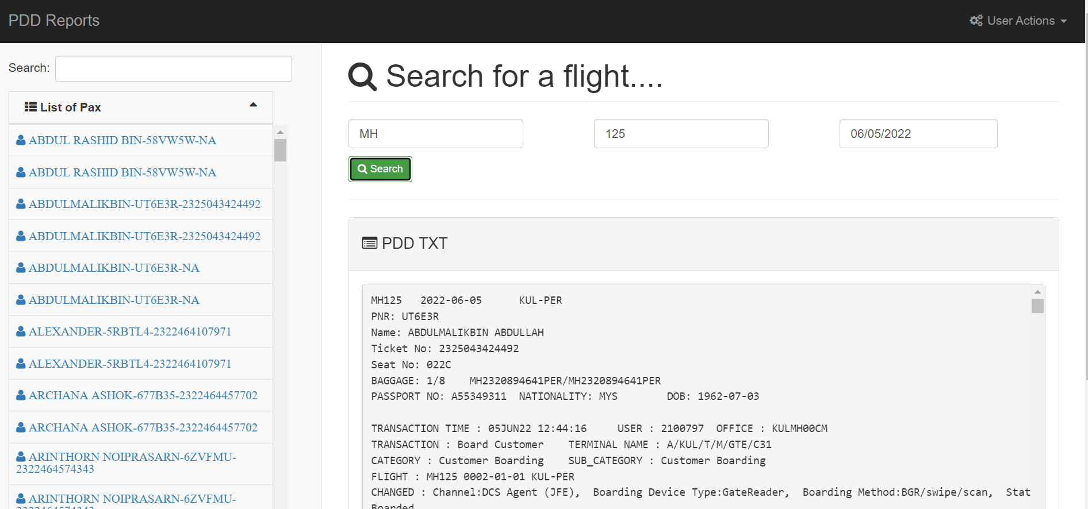

**RE-RUN job steps:**

**STEP 1.**When we received the given mail:

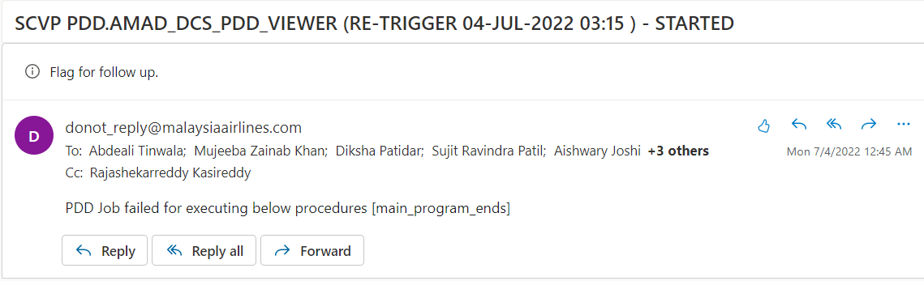

**STEP 2:** Use this query and hit into the database after u will get **6 count** result when the job is failed .

SELECT extract(hour from end_time) hrs,count(1) FROM pdd.execution_time_record

where date(end_time)=current_date group by extract(hour from end_time)

**STEP 3**.Open putty and login in your credentials:



1. Add **(su appadmn**) command and password(**8URm8FFs**)

2.After add (**java -jar /home/appadmn/scvjob/pdd/bin/PDD_RE_RUN.jar**) command

**STEP 4:**

After rerun the job u will get this mail

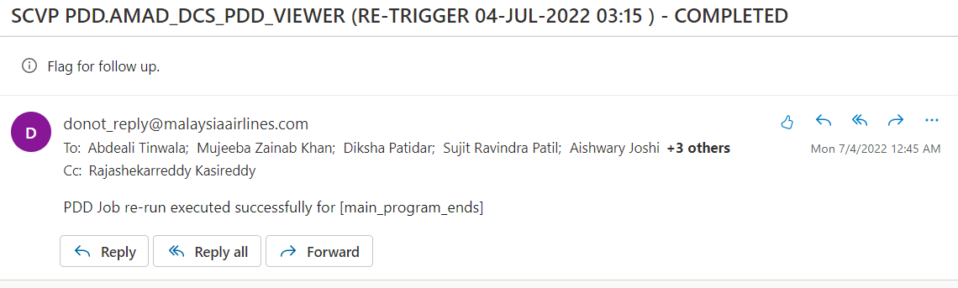

**STEP 5:**

After successfully rerunning job reverify the job count by using the below query (Expected result :8 count)

SELECT extract(hour from end_time) hrs,count(1) FROM pdd.execution_time_record

where date(end_time)=current_date group by extract(hour from end_time)